Verify Check  Cab  Cleanliness  Seat condition OK  Operator restraint provided  Instruments operational & labeled  Levers / controls operational  Pedals in good condition  ROPS to AS 2294  Windows / wipers / washers  Rear view mirrors  Operator instruction  (available on plant)  Verify Check  Warning devices  Horn  Reversing alarm  Verify Check  Warning signs (in cabin)  SEAT BELTS MUST BE WORN  Verify Check | Supplier verification & Plant details
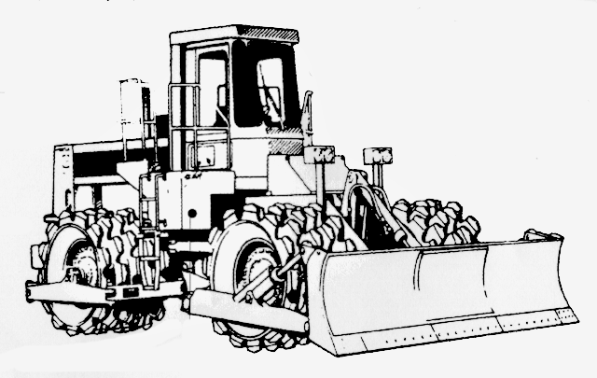 | Plant owner:
 | Address:
 | City/Suburb:
DANGER – SAFE WORKING LIMITS ON BATTERS  Ratio 2 to 1  example only. As per manufacturer’s specification | Phone:
 | Plant make:
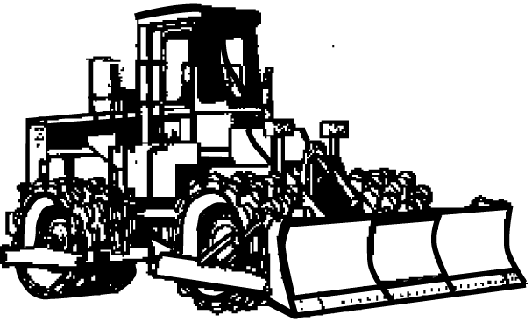 | Plant model:
Verify Check  Exhaust | Serial no.:
Verify Check  Engine guarding  Verify Check  Rams  Hoses  Connections  (check for excessive wear, leaks and creep)  Hydraulics | Signature:
 | Date:
Verify Check  Brakes  Park brake | Statement of operator competence required
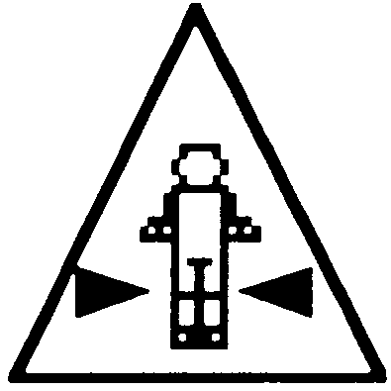  Verify Check  Crush point hazard  sign displayed both sides |  Plant to conform to manufacturer’s specifications and Plant Regulations.   Plant operator is to provide daily checksheets to WDA on a weekly basis.   Where applicable, Personal Protective Equipment must be worn.   Plant Log Book detailing service history in accordance with Manufacturer’s specifications should be written legibly in English.   Contractor must produce proof of competence of operator, e.g., Certificate of Competence, Licence, detailed Log Book
 | WDA use only
Verify Check | Note: Sign only when all items have been checked
Handrails  Steps | Plant check by:
Instructions:  Verify Box to be ticked by Owner / Supplier / Operator prior to arrival onsite.  Check Box to be ticked after visual inspection by WDA | Position:
 | Date: |  | / /

